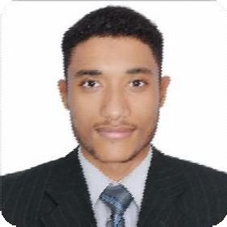

Personal Data
- Name: Mustafa Ibnidris Mokhtar Mustafa.
- Nationality: Sudanese.
- Date of Birth: 4/November/1992
- Place of Birth: Holy Makkah, Saudi Arabia
- Marital Status: Single.
- Languages:
- Arabic
- English, very good.
- Phone NO. : 0968222577. – Whatsapp +966552556210
- E-mail: mustafa_defjam@hotmail.com

Qualifications
- Bachelor of Medicine and Surgery, Almughtaribeen University – Khartoum, Sudan January 2016. With CGPA of 3.55/4, excellent class of award. BLS, June 2016.
- Gene and the Human Condition (From Behavior to Biotechnology), University of Maryland, College Park (Online course offered through Coursera).
- Part 1 Clinical Immunology residency, Sudan Medical Specialization Board.
- Molecular Medicine Msc holder, Institue of Emdemic Diseases, University of Khartoum.
- Part one Internal Medicone SMSB
- BLS 2016

Practical Experiences
- ICU resident at Hajj Al-Mardi Mohiuddin Teaching Hospital since 1/4/2022.
- Registrar of Internal Medicine at National Ribat University Hospital 24/5/2021 – 24/11/2021.
- Paediatrics resident 28/11/2021 till now 21/5/2022!
- Lecturer at Elrazi University – Internal Medicine Department.
- Medical officer at Umdownban Teaching Hospital January 2019 – April 2021
- Medical Officer at Khartoum Teaching Hospital -Internal Medicine and ICU- July 2019-July2021.
- Medical practitioner at Khartoum Hospiral of ENT, Sudan November 2018 – November 2019.
- Private tutor for medical sciences.
- GP in nephrology department of National Ribat University hospital, Sudan, January 2016 – November 2016.
- Internship year December 1st 2016 – November 30th 2017. According to the regulations applied by Umm Al-Qura University Faculty of Medicine, Makkah, Saudi Arabia.
- Saudi Commission For Health Specialties professional classification and registration record 25/4/2022..
- Altamyooz Emergency and Trauma Centre, 2018.

